
2.2.1 Catering to student diversity
2.2.1.The institution assesses the learning levels of the students after admission and organizes special programs for advanced and slow learners.
1. Online PGCET coaching is given for advanced learners and encouraged them to prepare for APPGCET & CUCET Exams.
Online PGCET coaching given to B.Sc. Zoology students by forming a group “Fathers of Zoology”.
PGCET online Links
S.No | Name of the topic | link
1 | Immunology | https://drive.google.com/file/d/1QCvUOjnFLt_61M5vX2KAHiqlwyV8It8h/view?usp=sharing
2 | Ecology | https://drive.google.com/file/d/1khNyFKJAdHdlHKFopyBodHnEid__vq6f/view?usp=sharing
3 | Ecology | https://drive.google.com/file/d/10wJvJJSSFM980vq81sh0cC8OgeuePn6e/view?usp=sharing
4 | Protozoa to Annelida | https://drive.google.com/file/d/1Pt6-Li0Q7QS2DRgXi9FcJAHFr7FYWApY/view?usp=sharing
5 | Fathers of biology | https://drive.google.com/file/d/16hC8dJONjyYO1xI0y9kLTaMcNWG5fTDB/view?usp=sharing
6 | Platyhelminthes & Nematoda | https://drive.google.com/file/d/1DYXe67CR1-NLSC0CmESLU8Ao98BxwxdF/view?usp=sharing
7 | Specialities of organisms & connecting links | https://drive.google.com/file/d/1iv0JRLod2BGRf05CwegmL9_7jwa83SlK/view?usp=sharing
8 | Important parasites & their hosts | https://drive.google.com/file/d/1qe6B_89rTMetRgM_WSgO35DKhiE7Vo20/view?usp=sharing
9 | Hereditary diseases | https://drive.google.com/file/d/1AT5qhzaqG0znK99CIRMvCkQVGqzf4Nd1/view?usp=sharing
10 | Dentition, Types of vertebrae & Types of joints, Sea animals | https://drive.google.com/file/d/1rD1p2HhPESLNoWYINvHnw5f5PMk1yLik/view?usp=sharing
Screen shots
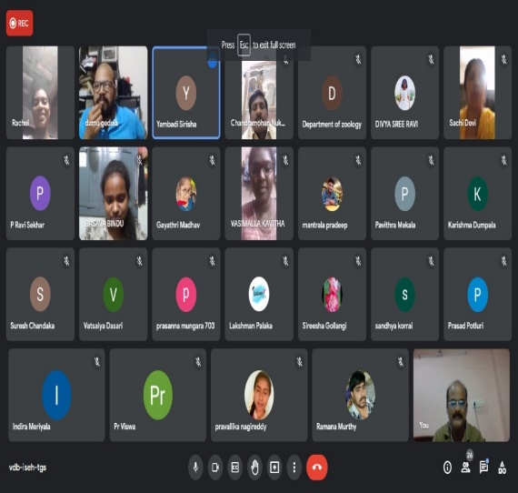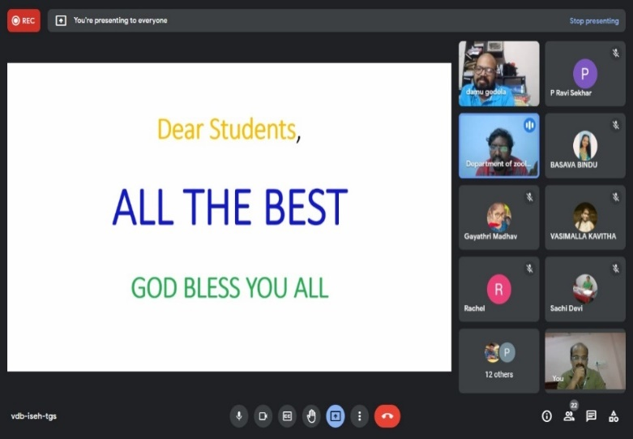

Names of students who secured Ranks in PGCET

PGCET-2021

S.No | Name of the student | Group | PGCET Rank | Rank in Women Category | Reservation rank
1 | M.Nagalakshmi | BZC EM | 235 | 188 | BC-D 35
2 | P.Suvarna | BZC EM | 724 |  | SC
3 | Shaik Mishbatarannum | Biotech | 625 | 79 | BC-E
4 | S.Nasreen | Biotech | 245
5 | P.Ramya Sri | Biotech | 1147 | 883 | NCC-53
6 | SMH Neelophur | Biotech | 662 | 517 | BC-E 83
7 | S. Mubeena | BZC EM | 3218
8 | S.Rasheeda Sultana | BZC EM | 2516
9 | N.Srivani | Biotech | 398 | 306 | BC-B 60
10 | P.Shivanandini | BZC EM | 914 |  | OC

P.Shivanandini secured 1727 rank in Aquaculture also.
S.No. | Name of the Student | Hall ticket Number | Class | Rank | Future Studies / Employment PG
1 | G.Anusha | 30401885201 | BtZC | 583 | YVU PGCET
2 | S.Reshma | 30401885072 | BtZC | 670 | YVU PGCET
3 | Shaik Mishbatarannum | 30401885138 | BtZC | 625 | YVU PGCET- Zoology

G.sampoornamma qualified CSIR- JRF In Chemistry and doing Ph.D.

Students of 2020-21 batch joined in higher education

S.No | Name | Group | Institute
1 | P.Ramya | BtZC | MSc. Biotechnology,YVU
2 | N.Rehana | BtZC | MSc. Biotechnology,YVU
3 | K.Subbamma | BtZC | MSc. Biotechnology,YVU
4 | Anjali saraswathi | BtZC | MSc. Biotechnology,YVU
5 | Srilakshmi | BtZC | MSc. Biotechnology,YVU
6 | Pavani | BtZC | MSc. Biotechnology,YVU
7 | S.Samreen | BtZC | MSc. Biotechnology,YVU
8 | SMH Neelophur | BtZC | M.Sc Zoology, YVU
9 | Om Latha | BtZC | M.Sc Zoology, YVU
10 | P.Suvarna | BZC EM | M.A. English, YVU
11 | K.Y. Sucharitha | BtZC | M.A. English, SKR & SKR GDC W (A)
12 | G. Bhavyasri | BtZC | MSc. Biotechnology, Sri Padmavathi Mahila University,  Tirupati
13 | Pallavi | BtZC | MSc. Chemistry, Sri Padmavathi Mahila University, Tirupati
14 | K.Nagalakshmi | BZC- EM | MBA, KLM Engineering College forWomen, Kadapa
15 | M.Yasoda Devi | BZC- EM | MBA, KLM Engineering College forWomen, Kadapa
16 | T.Lalithakala | BZC- EM | MBA, KLM Engineering College for Women, Kadapa
17 | K.N.Sireesha | BZC- EM | MBA, KSRM Engineering College, Kadapa
18 | Shanthi | BZC- EM | MBA, KSRM Engineering College, Kadapa
19 | Faiza Anjum | BZC- EM | MBA, KORM Engineering College, Kadapa
20 | C. Chaithanya Kumari | BZC- EM | MBA, KLM Engineering College forWomen, Kadapa
21 | G. Prasanna | BZC- EM | MSc. Chemistry, Sri Venkateswara University, Tirupati
2. Enrolment of students into certificate courses:
1 | Name of the Department | ZOOLOGY
2 | Title of the Activity | Certificate course onHealth and Nutrition
3 | Day and Date & Time | From Aug 6th 2019 to Sep 16th 2020
4 | Details of Resource persons | Dr. D. Aruna Kumari, Asst. Prof in Zoology  Dr.Sachidevi.P,Asst. Prof in Zoology  Smt B. Swarna Mary, Lecturer in zoology
5 | Name of the lecturers involved | CONVENER: Dr. D. Aruna Kumari, Asst. Prof in Zoology  CO-CONVENER :Smt B. Swarna Mary, Lecturer in zoology
6 | No. of Lecturers Participated | 02
7 | No. of students involved/Participated | 40
8 | Brief Report | The Department of zoology has held a CERTIFICATE COURSE on "Health and Nutrition" to create awareness among the students about healthy life style &well-being for building a healthy society.
9 | OUTCOMES | Students gained knowledge on  1. Healthy food habits  2. Balanced diet  3. Obesity  4. Regular exercise & Yoga
 | 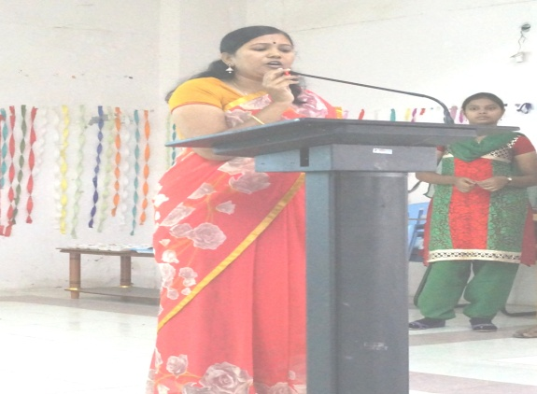 | 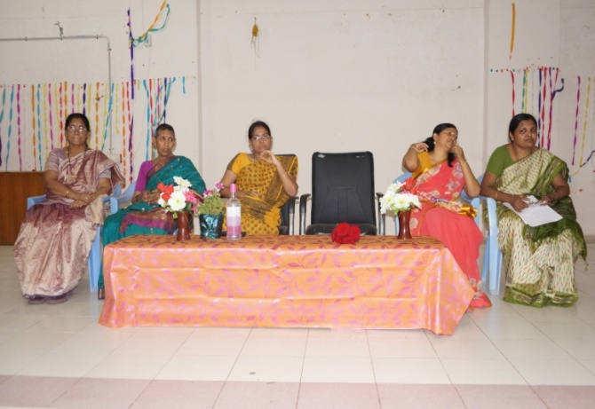
DETAILS OF STUDENT PROJECTS DURING 2021-2022
S. No | TITLE NAME | STUDENTS INVOLVED
1 | CULTURE OF FRESH WATER PRAWNs | S.ARSHIYA,S.FAHEEM BANU  S. TARFA, S. UMESHA, S. AMEENA.
2 | ORNAMENTAL FISHES AND MAINTENANCE OF AQUARIUM | N. LAHARI, J. VIJAYA LAKSHMI, C. DIVYA,  Y.SASI KALA.
3. | WOMEN’S ROLE IN FISHERIES | K. VISHNU PRIYA,C.JAHNAVI, B. SPOORTHI &C.SWATHI.
4. | PEARLS AND ITS CULTURE | G. LAKSHMI SWAROOPA, K. SANDYA, P. MANJULA&G.SARIKA.
5 | MIGRATION IN FISHES | P.PARVATHI,P.RENUKA,P.NIROSHA,R.SHIREESHA&B.SNEHA.
6 | MAINTENANCE OF AQUARIUM | P. PARVEEN, T.PAVANI,P.SIVANI,B.AMRUTHA &VARSHINI.
7 | FISH PROCESSING | M.DEEPIKA,M.SANGHAVI, Y. ARCHANA,A. MAMATHA.  V.GAYATHRI& Y PRABHAVATHI.
8 | FISH BY PRODUCTS | S.RESHAMA, S.SOFIYA, S.AMEENA BEEBI,AK AMREEN.
9 | TYPES OF CULTIVABLE FISHES | P. TEJASREE, C. CHANDBEE, S. REDDY DIVYA, P. SIVA MEGHANA, M.SUSHMITHA.

Advanced learners are encouraged to give seminars to revise the topics for slow learners.
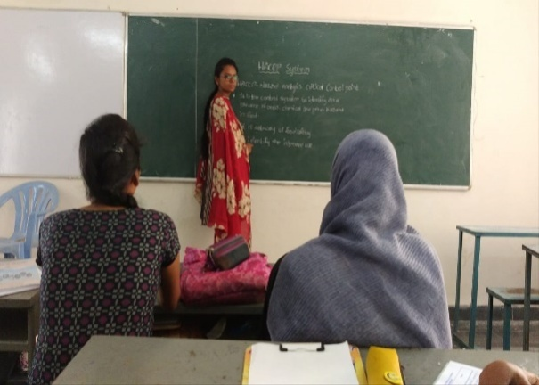 | 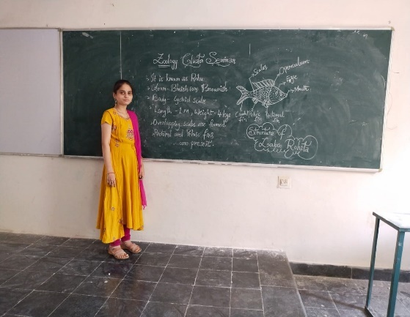
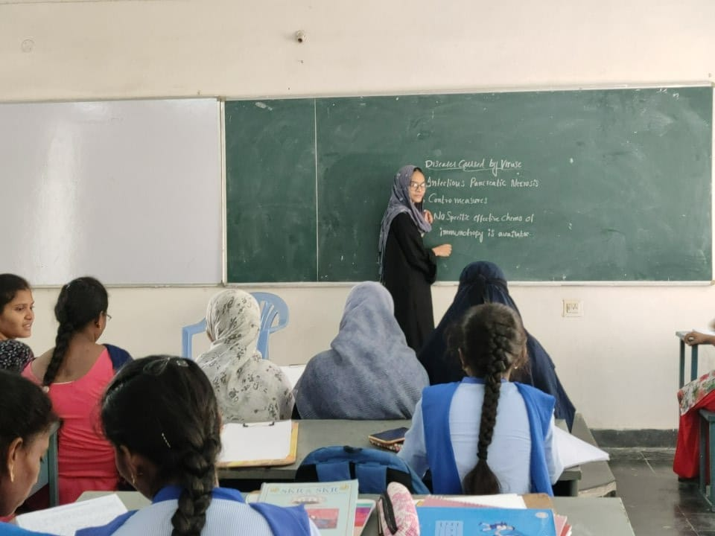 | 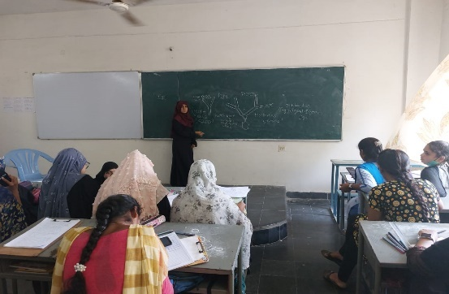

Teachers take PPT classes to enable the slow learners to understand the
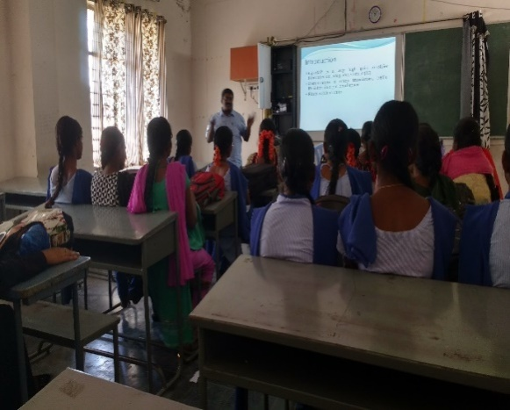
topics & remember them easily.
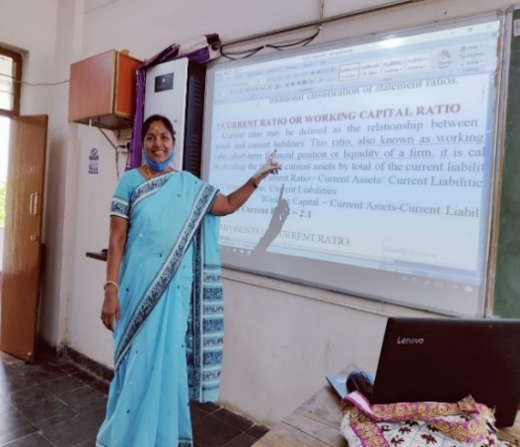
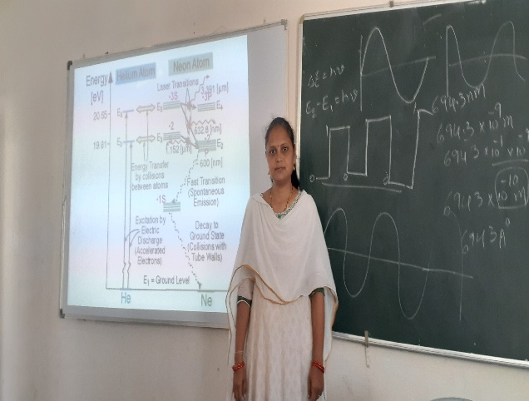
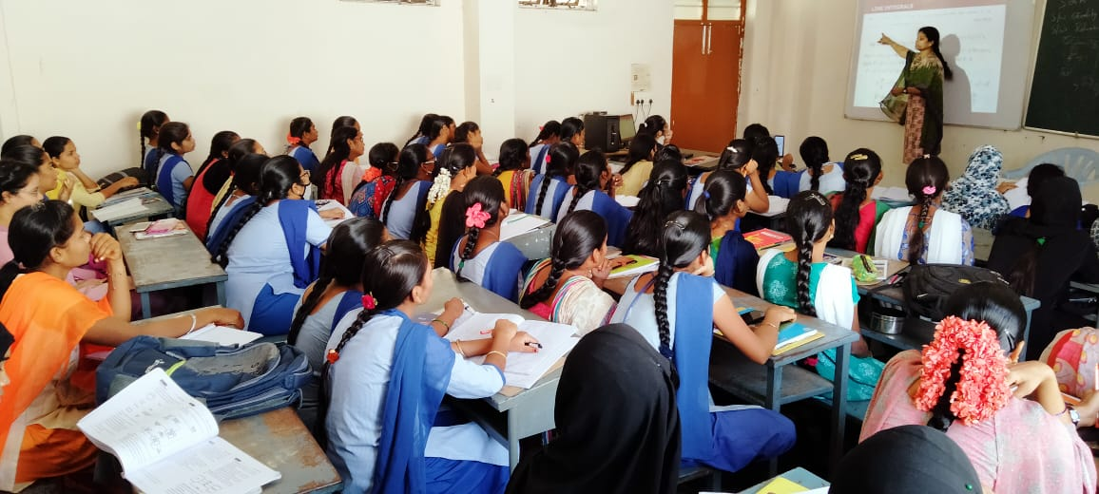

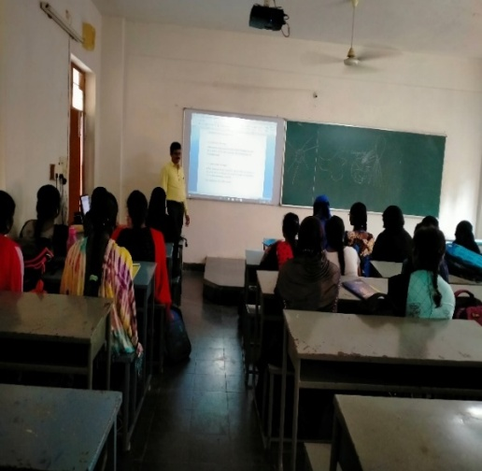
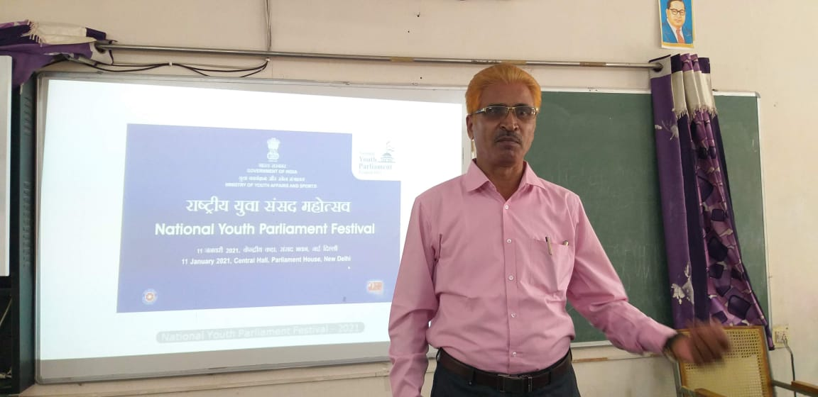

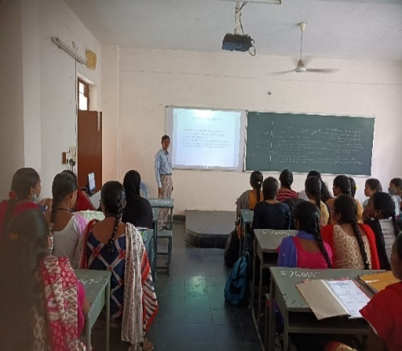
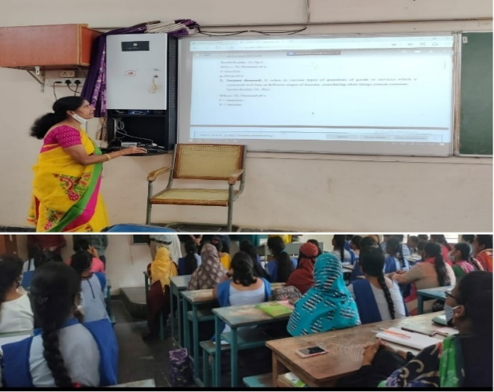

Students are encouraged to participate in quiz, Essay writing & Elocution competitions.

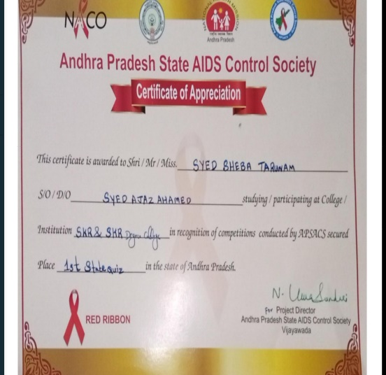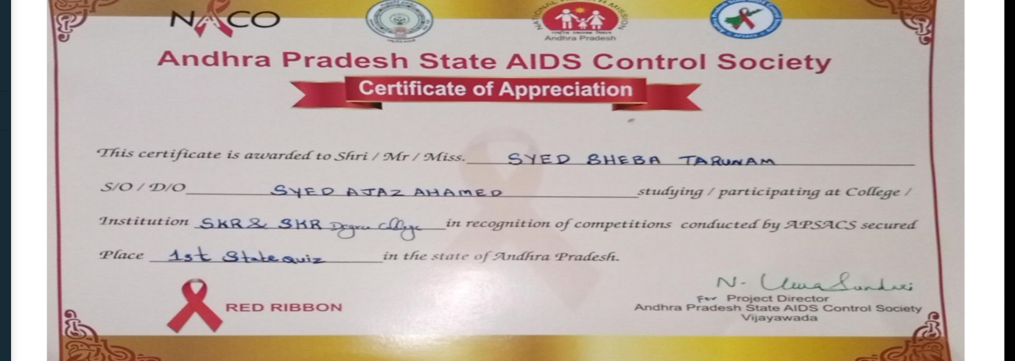
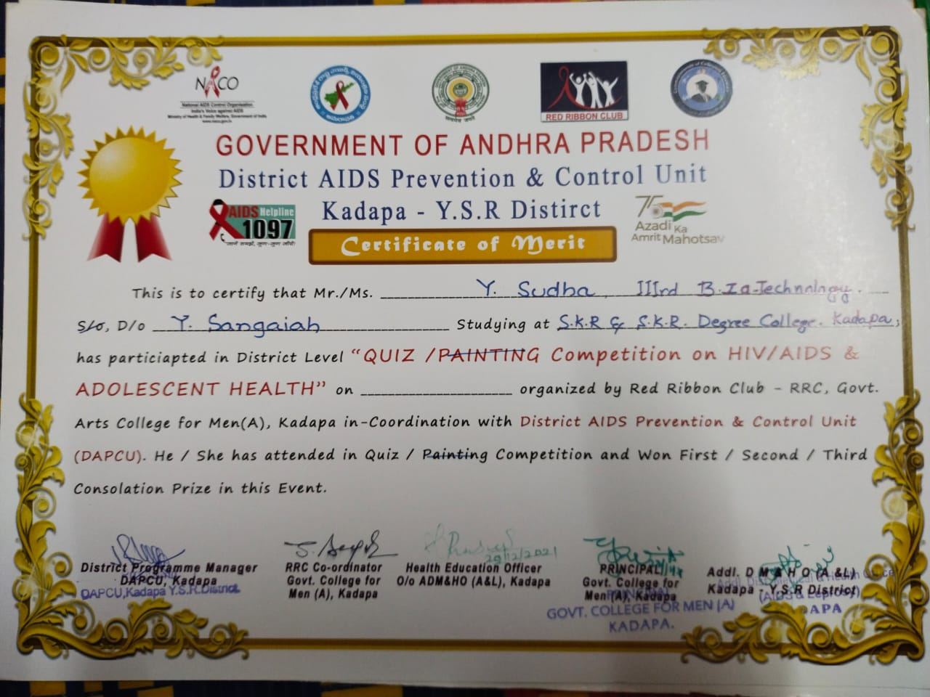

Quiz competition on AIDS & Tuberculosis.
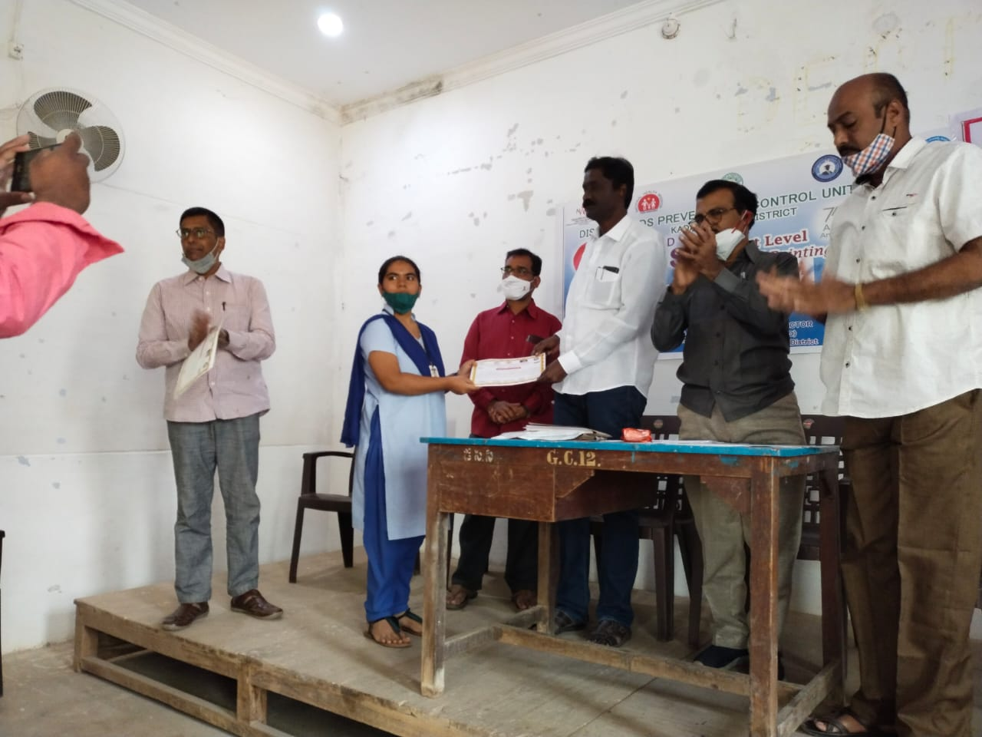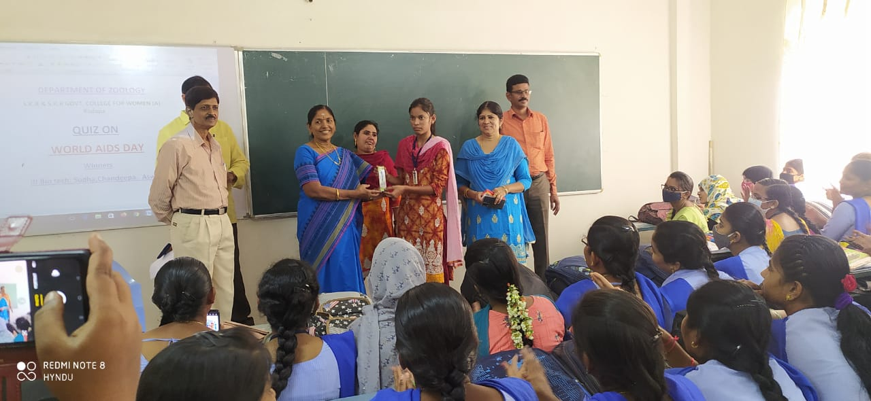
Drawing competitions Essay writing competition
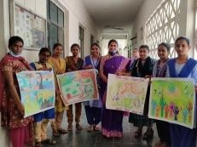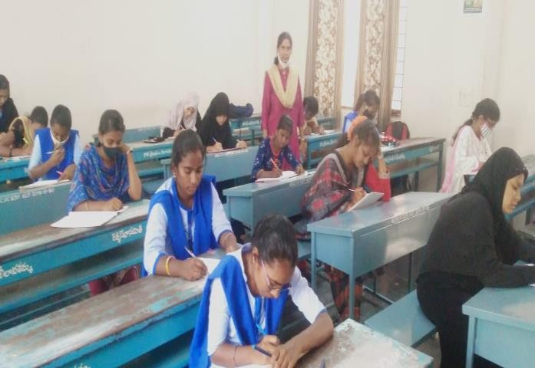
Implementing JKC Curriculum
JKC Training Programme is designed to help the students to grow as a professional. The training aims to sharpen the competencies of the students and give them right inputs on Technology and soft skills.
S.No | Component | No. of Hours
1 | Communication skills | 60
2 | Soft Skills | 30 soft skills,  10 Ethical Values
3 | Analytical Skills | 60
4 | Technical skills | 60
5 | General Awareness | 30
 | Total | 250

Selected Students Details for the Year 2021-22
S. No | Name of the Student | Group | Name of the Company
1 | P.Swathi | B.Sc(MSCs)  2019 passed out | Cognizant Technologies Pvt. Ltd
2 | A.Pavithra | B.Sc(MECs)  2021 passed out | Infosys Pvt. Ltd
3 | Sree Deepa Mallu | B.Com(CA)  2021 passed out | Wipro Pvt. Ltd
4 | S.Poojitha | B.Com(CA)  2018 passed out | HCL Pvt. Ltd
5 | Syed Afrin | III B.Sc(MSCs)  2022 passed out | Wipro Pvt.Ltd
6 | V.Anjali Saraswathi | B.Sc  2021 passed out | TCS Pvt. Ltd

S. No | Name of the Student | Group | Name of the Company | College
1 | M.BHARGAVI | B.Sc(MECs) | Bharath FIH Limited | GCW(A),  Kadapa
2 | C.MOUNIKA | B.Com(CA) | Bharath FIH Limited | GCW(A),  Kadapa
3 | K.MAHABOOB CHAND | B.Sc(MECs) | Bharath FIH Limited | GCW(A),  Kadapa
4 | E.NAGA PUJITHA | B.Sc(MSCs) | Bharath FIH Limited | GCW(A),  Kadapa
5 | T.SIREESHA | B.Sc(MSCs) | Bharath FIH Limited | GCW(A),  Kadapa
6 | B.PRASANTHI | B.Com(CA) | Bharath FIH Limited | GCW(A),  Kadapa
7 | A.JAYA SREE | B.Sc(MSCs) | Bharath FIH Limited | GCW(A),  Kadapa
8 | J.NAGA RANI | III B.Sc(MPCs) | Bharath FIH Limited | GCW(A),  Kadapa
9 | K.JYOYHI | III B.Com(CA) | Bharath FIH Limited | GCW(A),  Kadapa
10 | T.INDRANI | III B.Sc(MECs) | Bharath FIH Limited | GCW(A),  Kadapa
11 | S.MANASA | III B.Com(CA) | Bharath FIH Limited | GCW(A),  Kadapa
12 | L.ASWINI | III B.Com(CA) | Bharath FIH Limited | GCW(A),  Kadapa
13 | G.SRAVANI | III B.Sc(MPC) | Bharath FIH Limited | GCW(A),  Kadapa
14 | K.HARITHA | III B.Sc(MPCs) | Bharath FIH Limited | GCW(A),  Kadapa
15 | P.DEEPTHI | III B.Sc(MECs) | Bharath FIH Limited | GCW(A),  Kadapa
16 | B.PERAMMA | III B.Sc(MECs) | Bharath FIH Limited | GCW(A),  Kadapa
17 | S.K.JAMEELA | B.Sc(MPCs) | Bharath FIH Limited | Sri Shridi Sai Degree College  Jammalamadugu
18 | P.NAGA SUDHA | B.Sc(MPCs) | Bharath FIH Limited | Sri Shridi Sai Degree College  Jammalamadugu
19 | S.MABUDA | B.Sc(MPCs) | Bharath FIH Limited | Sri Shridi Sai Degree College  Jammalamadugu
20 | L.Madhavi | B.Com(CA) | Bharath FIH Limited | Sri Hari Degree College,Kadapa

Press Clipping from Sakshi
